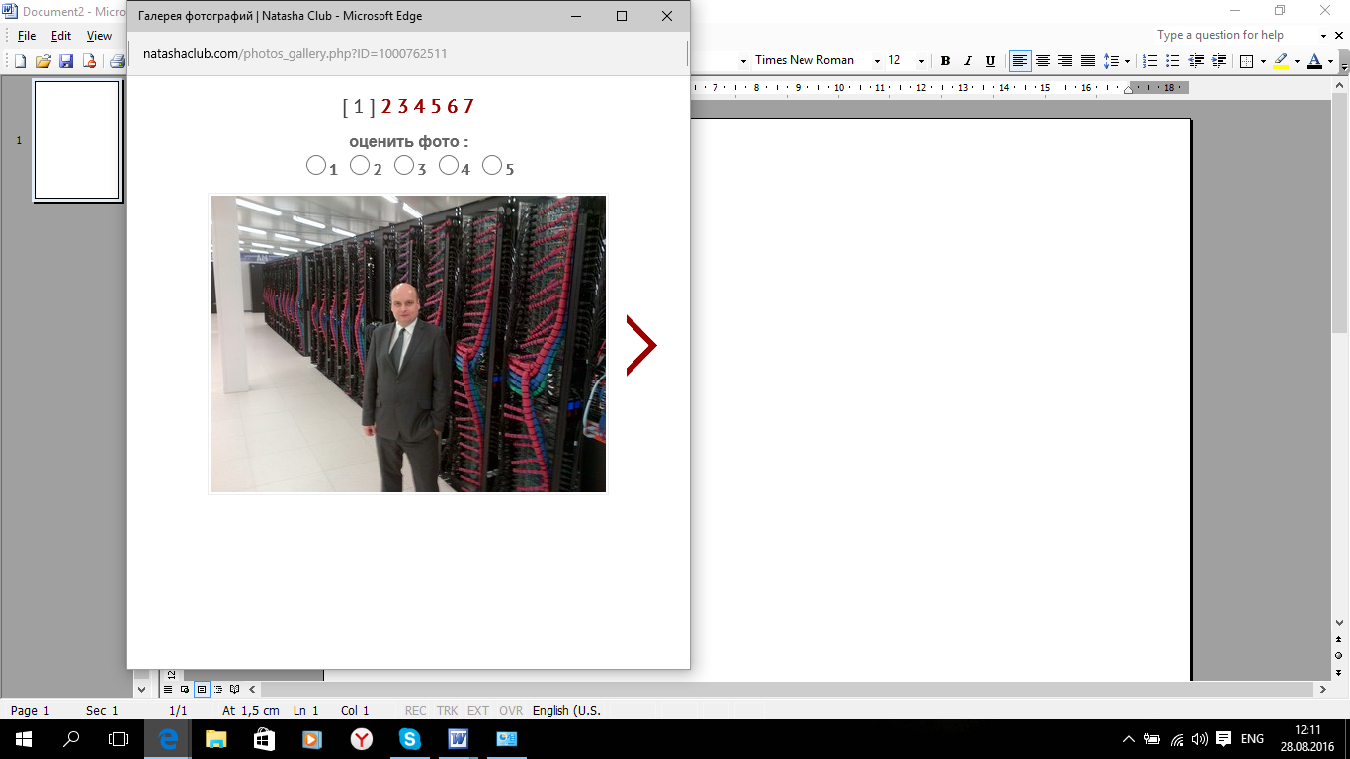

Dear Elena,
many thanks for your replies.
First of all, I am glad that you are safe and healthy. I can assume it was hard for you to travel home to Donetsk to your parents and to see your old hometown. Your parents will remain in Donetsk?
I have seen that you've sent me a couple of mails. I will try to answer you in one large mail and answer all your questions.
I have vacation now and therefore I was been in Opatija in Croatia for a week. Its a nice and old Autro-Hungarian city in the north of Istria close to Rijeka. I have enjoyed the week. I have two weeks left now and I might fly to Kyiv next week. I will see.
It is really a shame what happened in the Ukraine now. The country is very rich on natural resources, raw materials and agriculture. The people are good educated and open minded. I have been in Kyiv and Kharkiv for business and Odessa for private reasons. Beautiful cities! I also had in plan to move to Donetsk in 2014 but because of the war I didn't do.
Yes, my life is a bit different in comparison to others. I have two apartments in Ljubljana and close to Munich. Usually I am a few days working in Germany but the remaining I am in Slovenia. I can work in my home-office.
With quality of living I mean that Slovenia has many advantages. It takes me 1,5 hours drive to the beach or 1 hour drive to the Alps. The country is very green with forests and mountains and the cities and villages are nice. I live very good with my German salary in Ljubljana.
I also have a question to you. I have read that you have worked as prosecutor in the Ukraine. I have to assume its a very good job in the Ukraine. Do you like your job? I am asking because I think you will have issues to do something similar in any other country outside the Ukraine. What would like do or work if possible in another country?
Thank you
Have a lovely weekend
Big Hug
Christian

